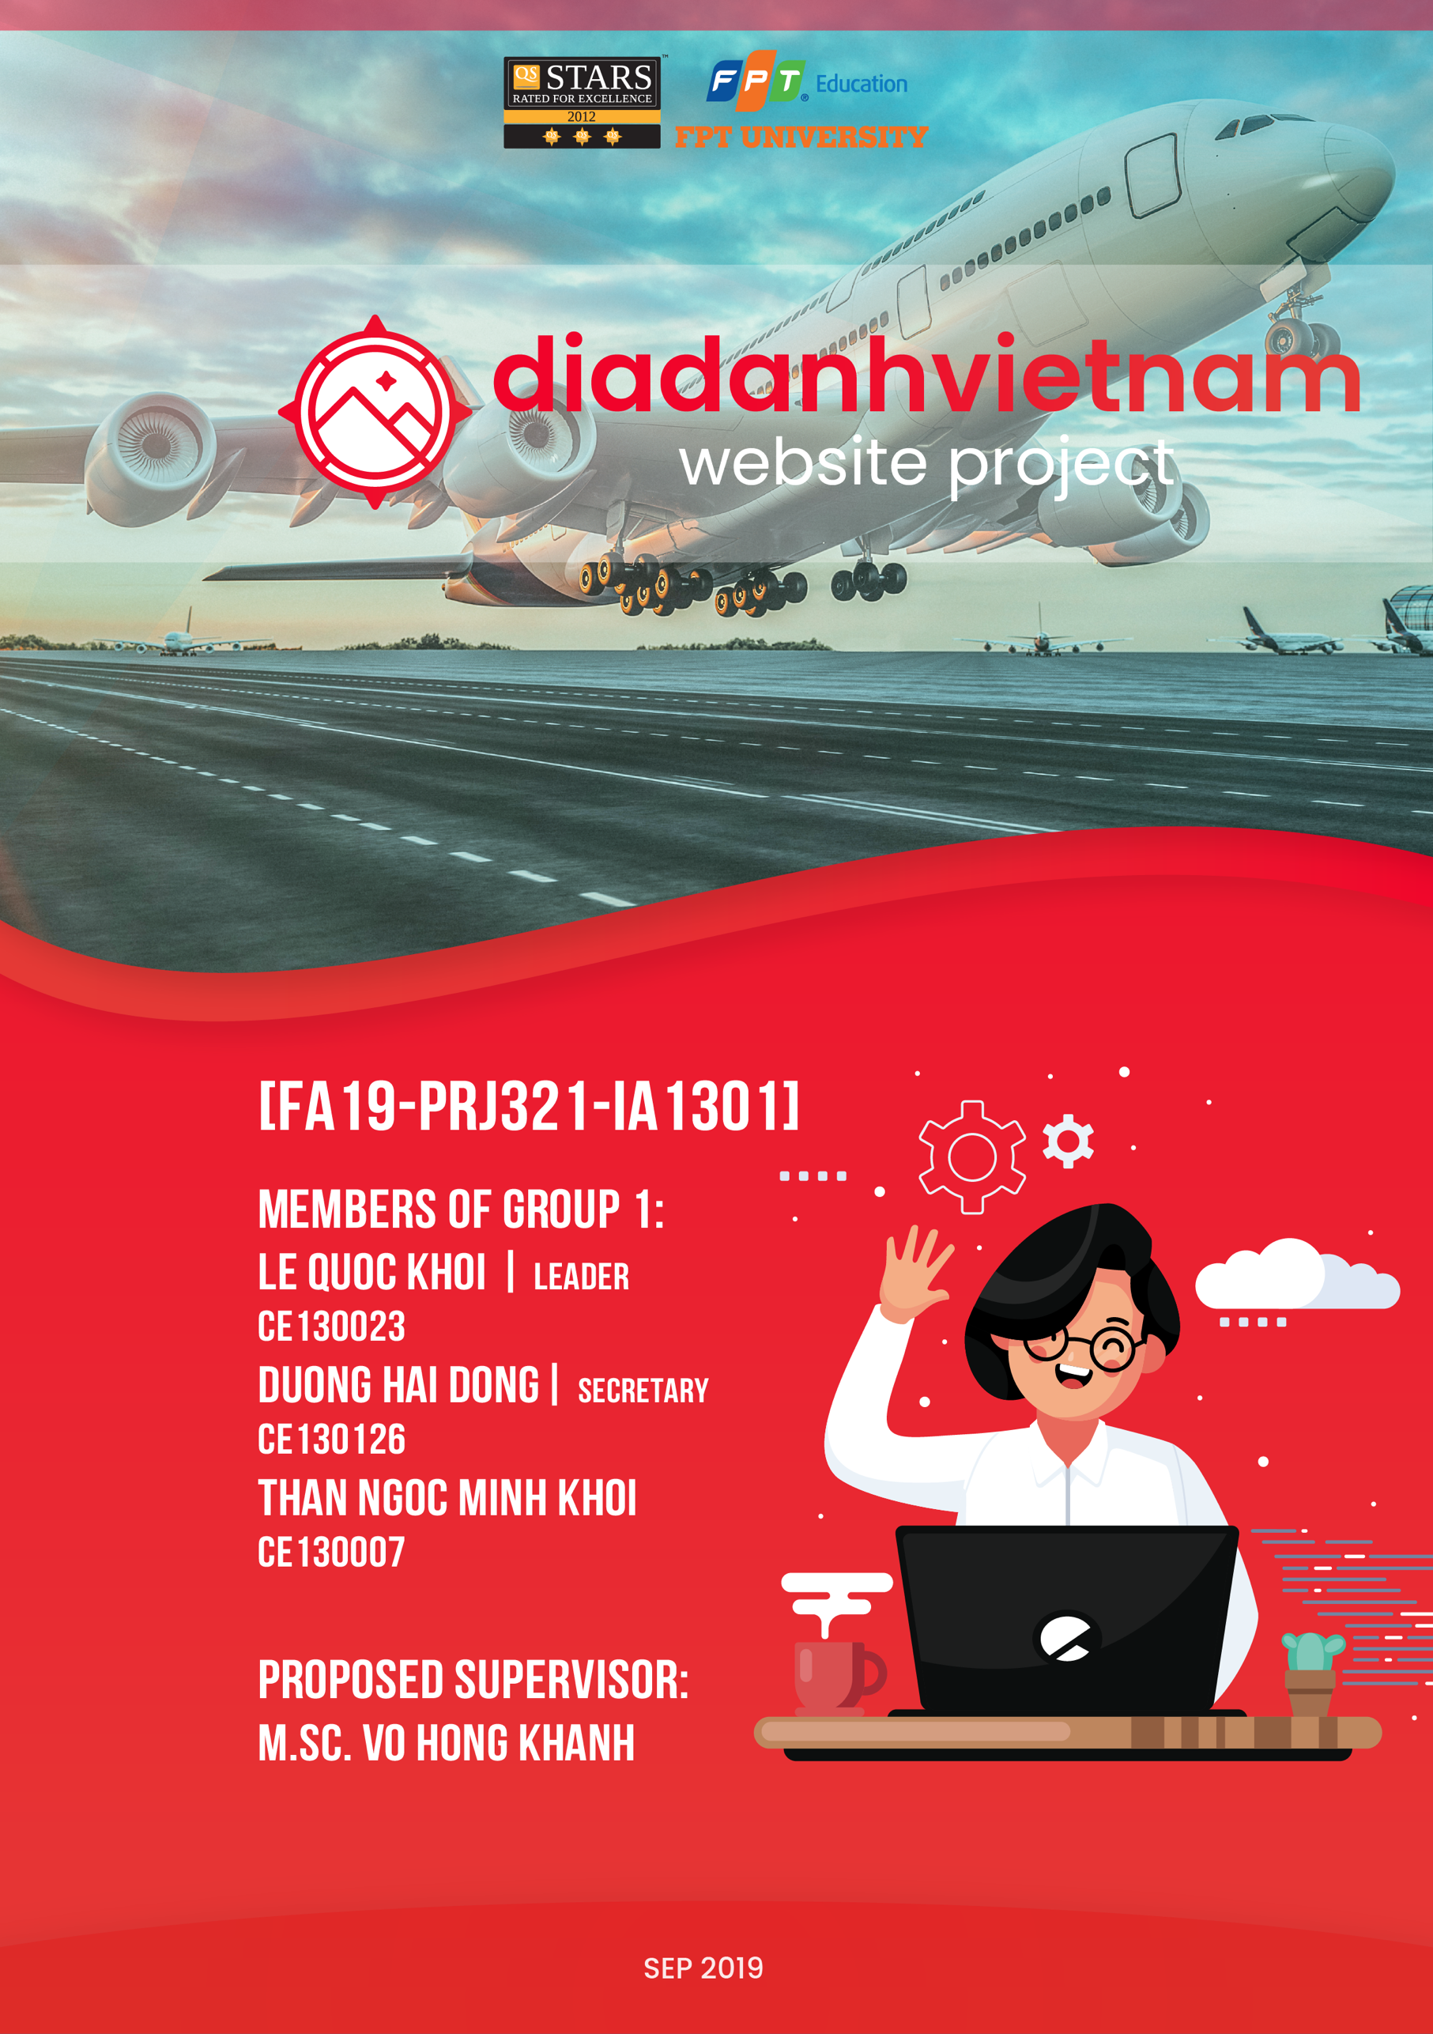

## I. Table of content

I. Table of content 2

II. Problem definition 3

III. User requirement 4

Functions 4

CRS Function 5

CRS Hardware/Software 6

CRS Acceptance Criteria 6

IV. Project details 7

V. Role & schedule 9

Role 9

Schedule 10

VI. Design 11

System organization 11

Data Structure 12

Class Diagram 12

User Interface 18

VII. Checklist 17

## II. Problem definition

Tourism is the making of a human trip, with specific purposes specific to another place that is not meant to be settled and returns after the trip. You want to relax your body after long working days, you want to go somewhere to explore, learn, relax ... you want to travel, but you don't know where to go, you want to find out where , landscapes, goals, regional culture like. If you want to see a review of the beautiful scenery in that location, please go to the Vietnam Places Web site.

Our website will help you see the beautiful scenery in the provinces and cities of Vietnam, you can read the review of the places and places you are visiting. Everyone can view the Vietnam web site online on their device and can easily see the tourist destinations they want, can comment on and rate other people's posts or they can Post your comments about how that place is so that everyone can understand the destinations together.

The page will include some functions like post-posting, browsing, viewing old posts. The post-post section will have:

- Title

- Content

- Rating

- Comment

- Date

- Author

- Thumbnails

After writers had posted their articles, these will be reviewed the main editor. If the article is accepted, it will be posted on the website Vietnam Places.

## III. User requirement

### Functions

For employee by role

Admin account: manage the mod, manage database

Mod: add new post, approved post, manage post, delete or edit post.

For client.

Clients do not need to login. They can visit our website to view articles, share about regions, travel destinations on their devices and can leave comments and likes.

Customers do not need to login. they can visit our website to view articles, share about regions, travel destinations on the device and can leave comments and likes.

On the search toolbar we have many specific categories that help you find information and tourist destinations accurately and quickly with just a few mouse clicks.

### CRS Function

### CRS Hardware/Software

|  |  |  |
| --- | --- | --- |
|  | User | Server |
| Hardware requirement | * CPU: Pentium 2.5 GHz or higher. * HDD: 128GB or higher   - RAM: 4GB or higher | - CPU: AMD Opteron 6272 2.1Ghz or higher  - RAM: 16GB or higher.  - HDD: 1TB or higher  - Network Interface Controller |
| Software requirement | - Operating System: mac OS 10.12+,Windows8.1+, Android and iOS.  - Chrome/Firefox  - JRE 1.7 or higher. | - MySQL Server  - JRE  - Glassfish Server |

### CRS Acceptance Criteria

## IV. Project details

**Client:**

Name of customer: **Vo Hong Khanh**

Address: FPT University, Nguyen Van Cu street, An Binh ward, Ninh Kieu district, Can Tho city.

Email: [khanhvohong@gmail.com](mailto:khanhvohong@gmail.com)

Phone number: 0976 755 191

**About us:**

Name of customer/company: **SUDO Group**

Address: FPT University, Nguyen Van Cu street, An Binh ward, Ninh Kieu district, Can Tho city.

Email: khoilqce130023@fpt.edu.vn

Phone number: 0379 168 797

* Date of project plan:
  1. Start: September 30th, 2019
  2. End:
* Project Vision/Objective:

**Project initiation/Requirement document:**

1. Customer and regarding of customer
2. Product information
3. Services information of the company.
4. Deliverables
5. CRS document
6. Design document
7. Installation manual
8. User Manual
9. Maintenance Manual
10. Code document (if client require)

- Plan:

* Review activities: Review 2 times in the classroom.
* Testing activities: Test code, test program after done.
* Demo activities: Demo 1 time in the classroom.
* Backup and recovery every time at Github, Google Drive.
* Major project milestones:

|  |  |  |
| --- | --- | --- |
| - | Definition problem |  |
| - | User requirement |  |
| - | Analysis |  |
| - | Design |  |
| - | Coding |  |
| - | Testing |  |
| - | Maintenance |  |

## V. Role & schedule

### Role

|  |  |  |  |
| --- | --- | --- | --- |
| **NO.** | **MEMBER** | **ROLE** | **RESPONSIBILITIES** |
| 1 | KhoiLQ | Group leader | Group activity management |
| 2 | KhoiLQ, KhoiTNM, DongDH | Analysts | Define problem, input, output, process |
| 3 | KhoiLQ, KhoiTNM, DongDH | Designer | Design interface  Design flowchart algorithm |
| 4 | KhoiLQ | Coder | Program all functions for applications |
| 5 | KhoiLQ, KhoiTNM, DongDH | Tester | Testing all functions |
| 6 | KhoiLQ, KhoiTNM, DongDH | Maintenance | Check and backup data |

### Schedule

|  |  |  |  |
| --- | --- | --- | --- |
| **DOCUMENT NAME** | **PLANNED**  **START DATE** | **ESTIMATED NUMBER OF DAYS COMPLETED** | **TEAM MATE NAMES** |
| Problem Definition | 30-Sep-2019 | 2 | KhoiLQ, KhoiTNM, DongDH |
| User requirement | 30-Sep-2019 | 2 | KhoiLQ |
| Checking document | 1-Oct-2019 | 2 | KhoiLQ |
| Project detail | 2-Oct-2019 | 4 | KhoiLQ |
| Design Data Models | 3-Oct-2019 | 8 | KhoiLQ, KhoiTNM, DongDH |
| Design Class Diagram | 5-Oct-2019 | 8 | KhoiLQ, KhoiTNM, DongDH |
| Code Entity All Class | 7-Oct-2019 | 12 | KhoiLQ |
| Code Exceptions All Class | 7-Oct-2019 | 8 | KhoiLQ |
| Code Landscape, Province Controller | 7-Oct-2019 | 8 | DongDH |
| Code Comment, Rating Controller | 7-Oct-2019 | 8 | KhoiTNM |
| Code Post, User, Post_Approval | 8-Oct-2019 | 10 | KhoiLQ |
| Code Class Testing | 9-Oct-2019 | 18 | KhoiLQ, KhoiTNM, DongDH |
| Test Java core | 10-Oct-2019 | 18 | KhoiLQ, KhoiTNM, DongDH |
| Data sample | 11-Oct-2019 | 18 | KhoiLQ, KhoiTNM, DongDH |
| Code Front-end | 14-Oct-2019 | 36 | KhoiLQ, KhoiTNM, DongDH |
| Connect Front-end to Back-end | 28-Oct-2019 | 120 | KhoiLQ, KhoiTNM, DongDH |
| Presentation Preparation |  |  | KhoiLQ, KhoiTNM, DongDH |
| Deadline |  |  |  |

## VI. Design

### System organization

### Data Structure

Table: post

|  |  |  |  |
| --- | --- | --- | --- |
| **FIELD NAME** | **DATA TYPE** | **CONSTRAINT** | **DESCRIPTION** |
| Id | Bigint(20) | PRIMARY KEY | The Id of post |
| Title | Varchar | utf8mb4_general_ci | Title of post |
|  |  |  |  |
|  |  |  |  |
|  |  |  |  |
|  |  |  |  |
|  |  |  |  |
|  |  |  |  |

### Class Diagram

*View at next page*

### User Interface

## VII. Checklist

|  |  |  |  |  |  |  |  |
| --- | --- | --- | --- | --- | --- | --- | --- |
| No | Works | Planned Start Date | Estimated number of hours completed | Completion time | Realtime number of hours  completed | Team mate names | Note |
| 1 | Synthetic documents | 08/07/2019 | 2 | 15:00  08/07/2019 | 2 | KhoiLQ | Complete |
| 2 | Problem Definition | 08/07/2019 | 3 | 15:30  08/07/2019 | 3 | KhoiLQ | Complete |
| 3 | User requirement | 08/07/2019 | 2 | 10:00  08/07/2019 | 2 | DongDH | Complete |
| 4 | Project detail | 09/07/2019 | 2 | 11:00  09/07/2019 | 2 | DongDH, KhoiLQ, KhoaPLA | Complete |
| 5 | Interface design document | 10/07/2019 | 3 | 13:00  10/07/2019 | 3 | DongDH, KhoiLQ | Complete |
| 6 | Checking document 1 | 11/07/2019 | 2 | 14:00  11/07/2019 | 2 | DongDH, KhoiLQ, KhoaNLA | Complete |
| 7 | Code: convexHull function | 11/07/2019 | 3 | 8:00  11/07/2019 | 4 | DongDH, KhoiLQ | Delay 1 hour |
| 8 | Code: inputPoint function | 13/07/2019 | 3 | 10:00  13/07/2019 | 3 | DongDH, KhoiLQ | Complete |
| 9 | Code: listPoint function | 15/07/2019 | 3 | 9:00  15/07/2019 | 3 | KhoaPLA, DongDH | Complete |
| 10 | Testing 1 | 16/07/2019 | 4 | 10:00  16/07/2019 | 3 | DongDH, KhoiLQ, KhoaPLA | Complete |
| 11 | Check and edit code 1 | 16/07/2019 | 3 | 11:00  16/07/2019 | 2 | DongDH, KhoiLQ, KhoaPLA | Complete |
| 12 | Code:errorMessage | 17/07/2019 | 3 | 20:00  17/07/2019 | 3 | KhoiLQ, DongDH | Complete |
| 13 | Testing 2 | 18/07/2019 | 2 | 9:00  18/07/2019 | 3 | DongDH, KhoiLQ, KhoaPLA | Delay 1 hour |
| 14 | Check and edit code 2 | 18/07/2019 | 1 | 10:00  18/07/2019 | 1 | DongDH, KhoiLQ, KhoaPLA | Complete |
| 15 | Testing 3 | 19/07/2019 | 3 | 9:00  19/07/2019 | 2 | DongDH, KhoiLQ, KhoaPLA | Complete |
| 16 | Check and edit code 3 | 19/07/2019 | 2 | 10:00  19/07/2019 | 2 | DongDH, KhoiLQ, KhoaPLA | Complete |
| 17 | Compile code | 20/07/2019 | 3 | 8:00  20/07/2019 | 3 | DongDH, KhoiLQ | Complete |
| 18 | Check and edit code 4 | 20/07/2019 | 2 | 8:00  20/07/2019 | 2 | DongDH, KhoiLQ, KhoaPLA | Complete |
| 19 | Complete the code | 21/07/2019 | 2 | 9:30  21/07/2019 | 2 | DongDH | Complete |
| 20 | Checking document 2 | 22/07/2019 | 1 | 10:00  22/07/2019 | 2 | DongDH, KhoiLQ, KhoaPLA | Delay 1 hour |
| 21 | Checking project and Complete project | 22/07/2019 | 1 | 14:30  22/07/2019 | 1 | DongDH, KhoiLQ, KhoaPLA | Complete |
| 22 | Complete the project | 23/07/2019 | 1 | 11:00  23/07/2019 | 1 | DongDH, KhoiLQ, KhoaPLA | Complete |

## 

|  |  |  |  |  |  |  |  |  |
| --- | --- | --- | --- | --- | --- | --- | --- | --- |
| **No** | **Document Name** | **Planned**  **Start Date** | **Estimated Number Of Days Completed** | **Start Time** | **Completion Time** | **Total time to complete**  **(Hours)** | **Team Mates Name** | **Note** |
| 1 |  |  |  |  |  |  |  |  |
| 2 |  |  |  |  |  |  |  |  |
| 3 |  |  |  |  |  |  |  |  |
| 4 |  |  |  |  |  |  |  |  |
| 5 |  |  |  |  |  |  |  |  |
| 6 |  |  |  |  |  |  |  |  |
| 7 |  |  |  |  |  |  |  |  |
| 8 |  |  |  |  |  |  |  |  |
| 9 |  |  |  |  |  |  |  |  |
| 10 |  |  |  |  |  |  |  |  |
| 11 |  |  |  |  |  |  |  |  |
| 12 |  |  |  |  |  |  |  |  |
| 13 |  |  |  |  |  |  |  |  |
| 14 |  |  |  |  |  |  |  |  |
| 15 |  |  |  |  |  |  |  |  |
| 16 |  |  |  |  |  |  |  |  |
| 17 |  |  |  |  |  |  |  |  |
| 18 |  |  |  |  |  |  |  |  |
| 19 |  |  |  |  |  |  |  |  |
| 20 |  |  |  |  |  |  |  |  |